**Notes On AtliQ Grand – Hospitality Domain Project**

Key KPI’s to show on dashboard

1. RevPar – Revenue Per Available Room
2. Occ% - Occupation % = Total Rooms Occupied/ Total rooms available
3. Revenue - Sum of Sales across all property for given time
4. DSRN – Daily Sellable Room Night ( Ex- Suppose out of 100 rooms in July month (has 30 days), 100 rooms are sold then DSRN = 100
5. SRN – Sellable Room Night –calculated at month level
6. ADR – Avg Daily Rate
7. Realization - Revenue generated from utilized room nights (URN) against Booked room Night (BRN) i.e Realization = URN/BRN

BRN = URN + No Shows + Cancellation

Key Inputs from BA:

* As per business analyst, the weekends are Friday and Saturday (Not Sat and Sunday)

But in .csv files weeks ends are given as Sat and Sunday.

We have to mark week and weekends labels to all dates accordingly

Steps: WEEKDAY(dim_date[date]) returns 1,2,3,4,5,6,7 from Sun --> Sat

So, create calculated measure as

day_type =

var wkd = WEEKDAY((dim_date[date]))

return if (wkd > 5, "weekend", "weekday")

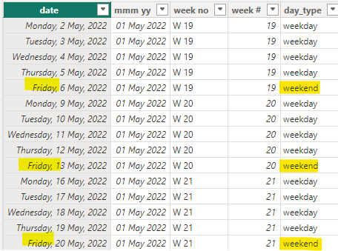

PowerBI Report : (New Link)

<https://app.powerbi.com/view?r=eyJrIjoiYWMxNzExZmQtYjFjZi00OGFjLTliNGYtODNlMzNhNzdmODc0IiwidCI6ImM2ZTU0OWIzLTVmNDUtNDAzMi1hYWU5LWQ0MjQ0ZGM1YjJjNCJ9>